***CODE TO LIST AND PRINT THE ELEMENTS IN DROPDOWNLIST***

**package** dropdown;

**import** java.util.List;

**import** org.openqa.selenium.By;

**import** org.openqa.selenium.WebDriver;

**import** org.openqa.selenium.WebElement;

**import** org.openqa.selenium.chrome.ChromeDriver;

**import** org.openqa.selenium.firefox.FirefoxDriver;

**import** org.openqa.selenium.support.ui.Select;

**public** **class** dropdownauto

{

**public** **static** **void** main(String[] args)

{

System.*setProperty*("webdriver.chrome.driver", "D:\\chromedriver.exe");

WebDriver driver = **new** ChromeDriver();

String baseUrl = "https://www.bing.com/account/general?ru=https%3a%2f%2fwww.bing.com%2f&FORM=O2HV65&id=language_section#language-section";

driver.get(baseUrl);

WebElement d = driver.findElement(By.*xpath*(".//*[@id='rpp']"));

d.click();

Select auto = **new** Select(driver.findElement(By.*xpath*(".//*[@id='rpp']")));

auto.selectByVisibleText("30");

List<WebElement> e = auto.getOptions();

**int** itemCount = e.size();

**for**(**int** l = 0; l < itemCount; l++)

{

System.***out***.println(e.get(l).getText());

}

}

}

**OUTPUT**

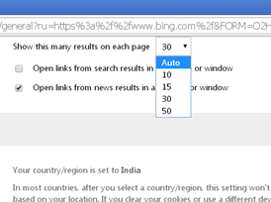

***CODE TO DISPLAY THE ELEMENTS IN DROPDOWNLIST***

**package** dropdown;

**import** java.util.List;

**import** org.openqa.selenium.By;

**import** org.openqa.selenium.WebDriver;

**import** org.openqa.selenium.WebElement;

**import** org.openqa.selenium.chrome.ChromeDriver;

**import** org.openqa.selenium.firefox.FirefoxDriver;

**import** org.openqa.selenium.support.ui.Select;

**public** **class** dropdownlang

{

**public** **static** **void** main(String[] args) **throws** InterruptedException{

System.*setProperty*("webdriver.chrome.driver", "D:\\chromedriver.exe");

WebDriver driver = **new** ChromeDriver();

String baseUrl = "https://www.bing.com/account/general?ru=https%3a%2f%2fwww.bing.com%2f&FORM=O2HV65&id=language_section#language-section";

driver.get(baseUrl);

WebElement d = driver.findElement(By.*xpath*(".//*[@id='setlang']"));

d.click();

Thread.*sleep*(3000);

Select auto = **new** Select(driver.findElement(By.*xpath*(".//*[@id='setlang']")));

List<WebElement> e = auto.getOptions();

**int** itemCount = e.size();

**for**(**int** l = 0; l < itemCount; l++)

{

System.***out***.println(e.get(l).getText());

}

}

}

**OUTPUT**

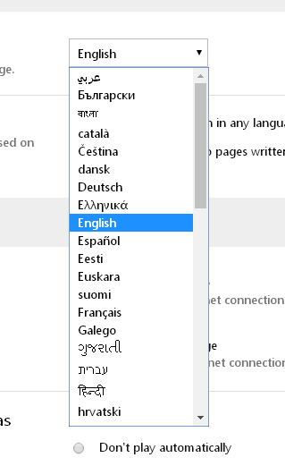

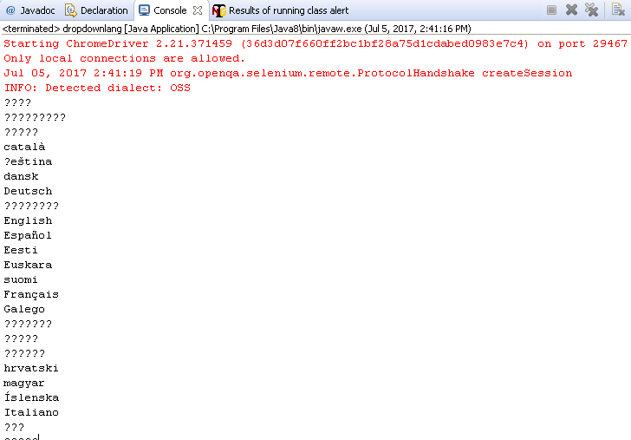

***CODE TO DISPLAY ALL THE LINKS IN A WEBPAGE***

**package** dropdown;

**import** java.util.List;

**import** org.openqa.selenium.By;

**import** org.openqa.selenium.WebDriver;

**import** org.openqa.selenium.WebElement;

**import** org.openqa.selenium.chrome.ChromeDriver;

**import** org.openqa.selenium.firefox.FirefoxDriver;

**public** **class** getlinks

{

**private** **static** String[] *links* = **null**;

**private** **static** **int** *linksCount* = 0;

**public** **static** **void** main(String[] args) **throws** InterruptedException

{

System.*setProperty*("webdriver.chrome.driver", "D:\\chromedriver.exe");

WebDriver driver = **new** ChromeDriver();

driver.get("http://www.tiliconveli.com/");

List<WebElement> linksize = driver.findElements(By.*tagName*("a"));

*linksCount* = linksize.size();

System.***out***.println("Total no of links Available: "+*linksCount*);

*links*= **new** String[*linksCount*];

System.***out***.println("List of links Available: ");

**for**(**int** i=0;i<*linksCount*;i++)

{

*links*[i] = linksize.get(i).getAttribute("href");

System.***out***.println(linksize.get(i).getAttribute("href"));

}

Thread.*sleep*(3000);

driver.quit();

}

}

**OUTPUT**

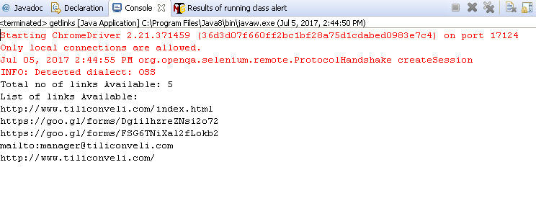

**PROGRAM TO PRINT THE TEXT IN ALERT**

**package** gmail;

**import** org.openqa.selenium.Alert;

**import** org.openqa.selenium.By;

**import** org.openqa.selenium.WebDriver;

**import** org.openqa.selenium.chrome.ChromeDriver;

**public** **class** alert {

**public** **static** **void** main(String[] args) **throws** InterruptedException{

WebDriver driver;

System.*setProperty*("webdriver.chrome.driver","D:\\chromedriver.exe");

driver = **new** ChromeDriver();

driver.get("http://demo.guru99.com/V4/");

driver.findElement(By.*name*("uid")).sendKeys("mngr86125");

driver.findElement(By.*name*("password")).sendKeys("AnUbUtA");

driver.findElement(By.*name*("btnLogin")).submit();

driver.findElement(By.*linkText*("Delete Customer")).click();

driver.findElement(By.*name*("cusid")).sendKeys("34940");

driver.findElement(By.*name*("AccSubmit")).click();

Thread.*sleep*(10000) ;

// Switching to Alert

Alert alert=driver.switchTo().alert();

String alertMessage=driver.switchTo().alert().getText();

System.***out***.println(alertMessage);

Driver.quit();

}

}

**Alert created by the page.**

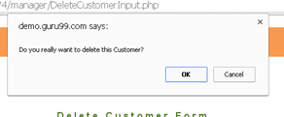

**OUTPUT**

Starting ChromeDriver 2.21.371459 (36d3d07f660ff2bc1bf28a75d1cdabed0983e7c4) on port 35956

Only local connections are allowed.

Jul 04, 2017 4:38:11 PM org.openqa.selenium.remote.ProtocolHandshake createSession

INFO: Detected dialect: OSS

Do you really want to delete this Customer?